On the road

The First Few Pages of Kerouac’s On the Road Filled My Head with Yearnings to Be One of Those Troublesome, Free-Spirited Guys Zigzagging Their Way Across America.

Memory is strange, the way it floats back at odd times, suddenly dredging up an image or song from the past. In just such a way, the 1960s song, This is the Dawning of the Age of Aquarius, popped into my head as I worked on my new fashion forecast on the fourth floor of my Paris house. That hippie anthem was full of hope and optimism yet today there are few signs of harmony and understanding where peace and brotherhood abound. Those optimistic years might be why they remain such a source of inspiration to the present generation. The 1960s music is still performed, the styles imitated and the slogans reused and distorted. The expression Turn on, tune in, and drop out was less an invitation to party in those days, more a call to experience life more intimately, more positively.

On the road
Everything was closely linked: the arts, experimental poetry, fashion, pop music, political and feminist protests as well as our huge get-togethers to raise money and launch projects. I remember someone asking at the time, “But what is it all for? What are you getting out of it—being a hippie and all?” The vastness of the question took me by surprise, especially as it had never occurred to me, or perhaps to others, to ask such an obvious question. The answer was simply the breathless exultation of being part of a movement that aimed to change the world.
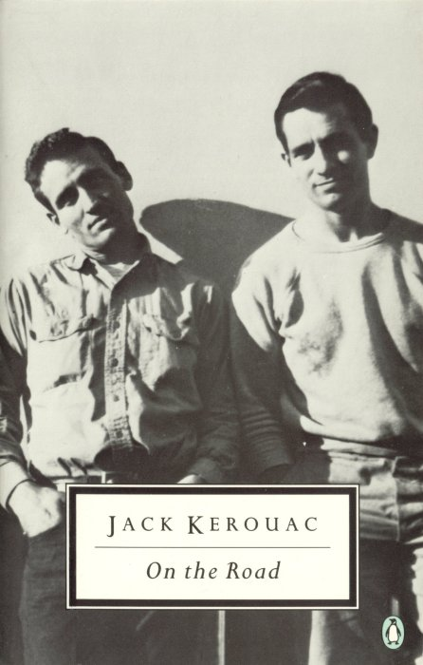
Without a doubt the hippie movement owes a debt to the early beatniks. They weren’t just bearded, laid-back guys, dressed in black. They were for the most part highly educated, their rebellion calculated to make a major impact on publishing restrictions with the aim to usher in a new kind of literary freedom. After the publication of Kerouac’s book On the Road and Ginsberg’s Howl, the laws of what was acceptable literature were broadened, experimentation was accepted and modern poetry underwent a relaxation of structure and style that allowed later writers to express themselves in freer mode. Poetry was thought to matter: art was in the world and of the world; that made it a part of our life.

One of my early paintings
It was in my third year of art school in 1959, while browsing a bookshop that I picked up Kerouac’s On the Road. The first few pages filled my head with yearnings to join those troublesome, free-spirited guys zigzagging their way across America in an old jalopy, hating mediocrity and reinventing every single moment. Kerouac’s voice was the voice I wanted to hear, a voice fed up with the notion that life should be measured in sensible portions. He asked the same questions I had been asking. Why go for mediocrity and routine when new adventures are out there, just waiting to be sampled? His example sent me hitchhiking that Christmas across Canada to see my brother Paul, who was completing his university degree in aeronautics at McGill in Montreal.
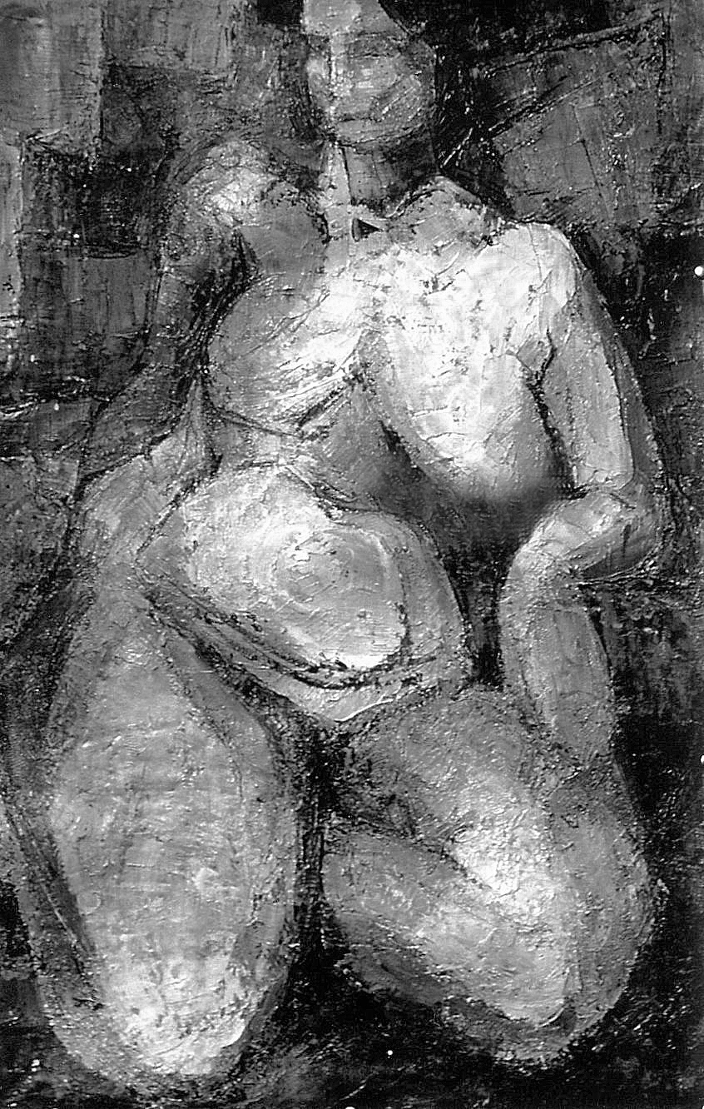
I had seen Paul often throughout the years on the Calgary communal university, polytechnic and art school campus as he shared his sandwiches with me at midday; a kind gesture that eased his guilt that our father paid for his studies, but not for mine.

Six year old me on the right with family at the end of the WWII
On my return to Calgary I met the artist Robin Page, destined to be my lifelong friend. He had hitchhiked in from Vancouver and Arts Center had given him a temporary job as caretaker. His black beard and extroverted manner distinguished him as a bohemian, almost to the point of his being a caricature of an artist. Overwhelmed by his powerful presence and attractive appearance, I could barely speak or register what he said. It was only when he smiled and revealed his damaged teeth that I saw him as human and just as approachable as anybody else.
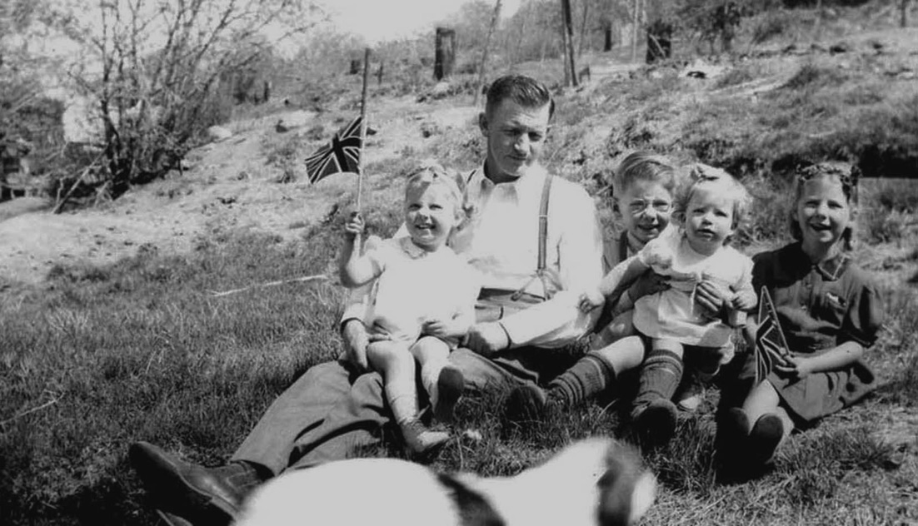
He was working his way across Canada on his way to Paris where he intended to meet like-minded artists, Vasarely and Agam, hard edge painters, whose work was close to his own. We became pals, not lovers and spent our evenings hanging out in our favorite coffee shop discussing art. His criticism of my art college, in the grip of abstract expressionism, gave me new perspective on my own work. His suggestion that I go to Paris and study with André Lhote, whom he called, ‘One of the world’s great teachers’, fit perfectly with my future plans.
A few months later Robin’s girlfriend Suzan, a strikingly pretty blonde with intense blue eyes arrived from Vancouver. “Karen is my girl-best-friend,” Robin told her naïvely, as if by introducing me that way he would calm any likely uncertainties she might have.
“And what exactly is a girl-best-friend?” She eyed me doubtfully, her frown revealing she thought I had most likely been coming on to her boyfriend.

Suzan
“Just good friends. You know, sister-brother like.”
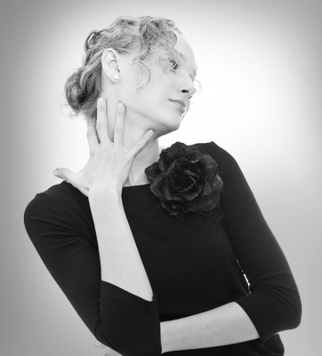
As the night wore on, I realized we had more in common than just liking the same man. We had both been to the January sales that day and bought fluffy, Parisian existentialist type jackets that slipped on over one’s head like a jumper. No sooner had I made that discovery than I saw she had a copy of On the Road in her handbag. When I mentioned the book she quoted several passages with a sly look at Robin. “I’d just love to be doing what I want, like those guys. You know, answering to no one. Being a guy, that’s real freedom.”
And so it went until one spring day in the coffee shop, I asked, “Why can’t we be guys?
“Yeah,” she said. “Let’s hitchhike to San Francisco.” Once the idea was voiced, there was no stopping us; the next morning we hit the road. In true Kerouac spirit, we should have driven those one thousand, five hundred miles in an old jalopy, but neither of us had a car or knew how to drive.
I didn’t bother to tell my parents about our trip. Leaving home had been a compromise; I could go to art school, but Dad would not pay. It wasn’t just that he was tight-fisted; he had the money to help me, but for his generation, a woman’s place was not only in the home, but in the wrong. Education for a girl was a risk; I might get above my female station. Compared to that, he would probably have thought hitchhiking across countries insignificant. My parents were used to my disappearances. At the age of six, I had taken to the road in earnest with little regret except to leave my baby sister Fay behind. I couldn’t take her with me, she was too young, so I’d packed my new shoes in a paper bag stuffed with my beloved toys and took off.
When Fay was born, I’d overheard my aunt say that my father was angry because she was not a boy. From that moment I knew I was no longer the only unloved kitten in the litter. Life was never quite so lonely after that. It wasn’t that my parents were cruel or my life unbearable; it was just that I couldn’t be what they wanted me to me. When I read Victor Hugo’s Notre Dame de Paris as a child, I was convinced that, like Esmeralda, I was a changeling – exchanged by the gypsies – who had been put in the wrong place and the wrong home.
On that first venture I did not get far. My father, returning from work in his beat-up Ford, caught me on the winding mountain road several miles from home, the rumble of his pickup truck unmistakable as it made its way up the steep incline. When it pulled up next to me I waved. “Hi, Dad.”
He poked his head out the window and looked at me quizzically. “Where do you think you are going?” I don’t actually remember my answer, but my refusal to return made his face grow red and his eyes narrow. “I’m not gonna take any nonsense from a little pipsqueak.” He got out of the car and grabbed my bag of toys. “I’m gonna give these to your sisters.” On the ride home, I whimpered and looked back at the mountain that I had almost reached. It was neither the first nor the last time that I felt life was unjust.
Hitchhiking might sound romantic, but the problems started as soon as Suzan and I were dropped off at the nearest US border, two hundred miles south of Calgary. Suzan twisted her long blonde hair nervously around her fingers. “Hey,” she said as we stood in the street thinking how were we going to get across without a passport. “Maybe they’ll put us in prison.”
“We’ll take a bus,” I said, worried that she was going to quit on me. Like so many schemes hatched out of desperation, it seemed like a good idea; even Suzan was pleased with it. We bought tickets for the nearest US town, but when the bus got to the border, the plan started to unravel. At first, I was puzzled by the way the customs inspector gave Suzan funny looks, until I took a good look at our fellow passengers. Beatnik clothes would not raise an eyebrow today, but in 1959, normal was twin sweater sets, longish skirts and bobby socks. Our black art school existentialist outfits and black stockings, complete with long hair and pale lipstick made us stand out like space aliens taking a holiday on Planet Earth. Oh, God! He probably thinks Suzan’s off to Hollywood. She was too pretty and although blonde, she made an effort to be a Juliette Greco look-a-like; the famous 1950s Saint Germain singer and Existentialist. The inspector was not so interested in me: just a kid, he was probably thinking. Nevertheless, he kicked us both off the bus in the middle of nowhere, with only a kind of shack offering snacks and coffee.
“So much for your ideas,” Suzan said dismissively.
“Listen, I know the next border crossing. It’s near my hometown, two hundred miles west.” She looked very reluctant until I asked, “Where is your Kerouac spirit?” No sooner had I spoken than a red station wagon with three unreliable-looking guys in baseball caps stopped nearby. “Are you going anywhere near Kamloops?” I asked hopefully.
“You wanta go there?” asked the driver, a sweaty, florid faced kid with some serious acne scars. “We ain’t doing nothin’. Get in.” As soon as we got in, Suzan started complaining and giving them a run-down of our troubles.
“You wanna cross the border?” the driver asked, giving a wink to the others. “Me and the guys will run you across the back hills. C’mon, it’ll be fun.” I was getting scared. Suzan was attracting too much attention from the wrong sort of guys.
“Thanks,” I said, “but my dad’s the chief of police in Kamloops, and if you’ll just drop us there, I’m sure he’ll take us across.” I saw them glance at one another and back at Suzan. For once, she knew enough to keep her mouth shut.
In Kamloops, we belted down to the Greyhound Bus café, where I dragged Suzan into the ladies’ toilet and rummaged through her bag. “You have got to look like a girl off to visit her aunt across the border.” It wasn’t easy to convince her to change her style. She particularly hated removing her black eye make-up and tying a scarf over her beautiful hair.

Suzan’s look alike Juliette Greco
This time we crossed the border without a problem, but Suzan having bought into her role wholeheartedly she couldn’t stop living it. For an hour in the bus, she gave the man next to her glimpses of her imaginary, strait-laced aunt while I tried not to laugh. “Oh, I’ve never hitchhiked,” she exclaimed as she leaned into the man’s face—her special technique, as she called it, to persuade someone she was telling the absolute whole truth. “Auntie Pru wouldn’t approve!”
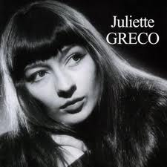
On the outskirts of Spokane, Washington, two boys driving down to Portland, Oregon, on the Pacific coast, picked us up. Initially they wanted to take us home to meet their mom, and Suzan, hoping for a free bed for the night, wanted to take them up on it. “No way!” I told her emphatically. The way our luck was going, I suspected we were likely to get more than we bargained for.
Disappointed by my attitude and perhaps to get even, the boys dropped us off near the Portland docks, a seedy, rundown section of town. At a hotdog stand, where we got something to eat, the vendor directed us to a shabby hotel. To cut the expenses Suzan insisted I take a single room while she climbed the fire escape and crept through the window. On that cold, damp night, Suzan, high up on the staircase had the look of a blue angel hovering over the area. This image apparently didn’t detract one wino, who called up from the alley, “Wanna make a quick fiver?” We didn’t know it then, but we had stumbled into the red light district.
In the clear light of morning, Skid Row looked even more sinister. Shabby men lounged on street corners, and broken bottles littered the sidewalk. At breakfast, in a small café, a bearded man sat down next to us and began talking to Suzan about Jesus and the second coming and whether or not she was ‘prepared’. Suzan nodded and agreed with his religious ranting, only telling me later she’d been counting on him paying for her bacon and eggs.
Separating her from her would-be mentor became quite an ordeal as he was convinced that she had been converted to his faith and he wanted to take her off to his church, whatever that might be.
Two trusty policemen put us on the right highway, and we headed down the coast toward San Francisco. Distance became illusionary as days merged into nights in a sleepless blur; we no longer stopped at hotels but traveled all night, hopping from one car to the next.
About six in the morning a couple of days later, we rocketed into San Francisco. The driver, a young boy about our age, refused to let us off in the run-down area of North Beach. He insisted, “It is full of beatniks and far too dangerous.” Such was the power of a few rebel poets and writers to inspire fear.

No home in San Francisco

In the Percolating Underground of the Beat Community, I Recognized my own Impatience for Talk, for Joy, and Perhaps Enlightenment.

The April fog hung in ragged streamers above the Bay area as we dragged ourselves out of the car and walked the final mile to North Beach. The first thing I noticed was how the beatniks were dressed. The original beatnik look adopted by Kerouac’s generation in the fifties was from the young Marlon Brando, the motorcycle-riding rebel in the film, The Wild One.

The Wild One
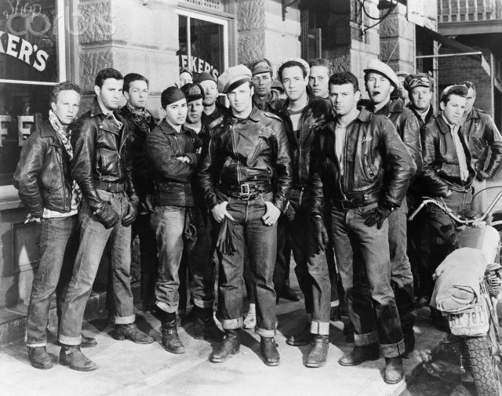
Brando wore a tee shirt and jeans, signaling his desire to be affiliated with the working class. His leather bomber jacket connoted the heroic derring-do of the World War II fighter pilot. By 1959, the look had evolved into something more self-consciously ‘artistic’ with beards, French berets and dark sunglasses (a nod to the black jazz musicians).
Surprisingly, the girls looked just like us. In Canada, Suzan and I had adopted that art school look: long hair, black stockings and blackened eyes, not in imitation of the beatniks – we hardly knew what they looked like – but in imitation of the arty French Existentialists that hung out in Sainte-Germain-des-Prés. The head of my art school, an old fuddy-duddy, had threatened to ban me from the college for looking too rebellious. Rebellious maybe, but more likely my thick black stockings were, in an old-fashioned way, too provocatively sexy.

City Lights group: Donlin, Cassidy, Ginsberg, Lavigne, Ferlinghetti
We rented a room in a reasonable hotel in North Beach, the heartland of the beatnik community. Unfortunately, after a couple of days, the owner saw us with those ‘good-for-nothing beatniks’ and decided we were undesirable guests. “I run a respectable place here. I only gave you a room because you came from out of town and didn’t look like lesbians,” she growled, as if we had somehow insulted her. “But I’m not having people like you in my hotel.”
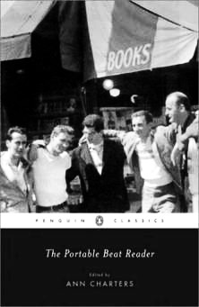
There was nothing for us to do but shrug, pack up our possessions and leave. “I didn’t like that place anyway,” Suzan said, puffing under the weight of her bag. “You know what that woman’s problem is? She’s mixed up. She thinks, like the straight world, that nonconformity is one bundle: intellectuals, painters, dropouts, sex perverts and dope fiends.”
I nodded. “Our freedom scares her. Damn it! Europeans fled to America to be free. Now we’ve got to go to Europe to be free.”
Suzan nodded enthusiastically. “Right, Europeans have seen it all. I bet we could dress like we do, hang out in cafés discussing heavy stuff all day and nobody would blink.”
Now the closest Suzan ever came to Europe was watching old French movies, but she was right; Europeans do tend to accept rebels, loners and eccentrics as a part of their society.
My Danish father had always objected strenuously to North American conformity. “At least we who live in a small community can believe in the ideals that helped to create America. We can make it like we want, but city dwellers—” he commented one day, shaking his head in dismay.

The Bagel Shop Notice
I had pondered his words for many days before asking him what he meant. “It’s all very complicated, but the folks in the city think that experts know best. They conform and let other guys tell ’em how to live.” He sat in his chair, his newspaper on his knees, while I waited for him to continue. He seemed to hesitate between his desire to return to his paper and the novelty that one of his children was actually listening to him. “During the Depression, the cities suffered. Unlike country folk, they starved, and now for them work is just a job.” Only later did I understand he was saying that work as man’s self-expression had ceased.
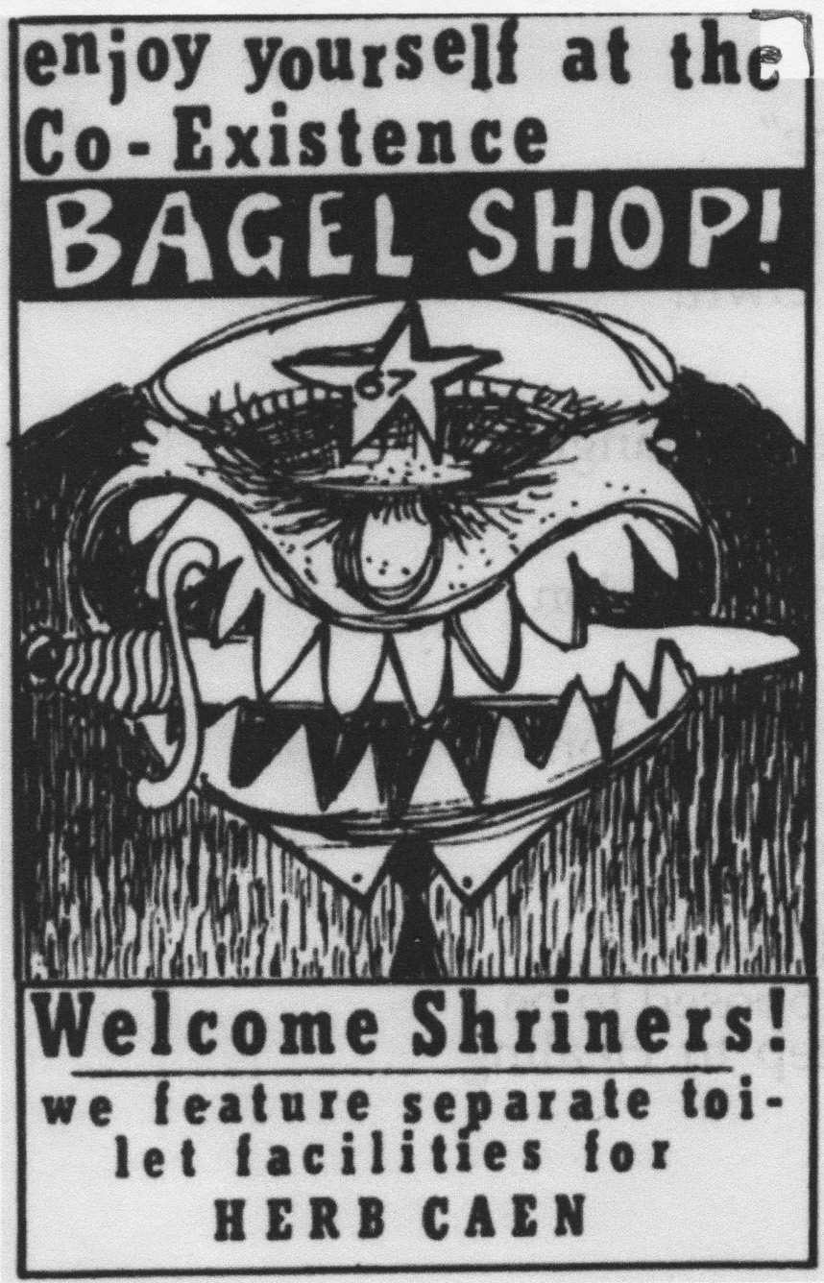
We sat dejectedly sipping coffee until a young journalist friend mentioned he had a room to rent on the roof of his building. The room, as it turned out, was just big enough to hold a double bed, but the location, perched like a white seagull on the slopes of Telegraph Hill, had spectacular panoramic views of the city. The whole building was enveloped in the salty smell of the sea and the sharp tang of sourdough bread floated up from the bakery below our window. We were enchanted and managed to ignore the owner’s too-friendly impromptu visits and his constant suggestion that we take our showers in his apartment. As the days passed, we discovered that the enormous terrace was a perfect place to read and the tiny room more than big enough for the short hours that we slept. But then, we had little time for sleeping. We were too busy exploring the beatnik territory and getting to know the inhabitants.
The San Francisco press was quick to denigrate the Beat movement as a resident phenomenon and treated the Beat writers, poets and artists as purveyors of childish nonsense. They mocked the black-legged girls of so-called ‘easy virtue’ who hung around Grant Avenue with the bearded, long-haired men. It was not just the look that antagonized them, but the idea that a rebel group could turn against the American good life.
In that percolating area of misfits and rebels, the City Lights bookshop was the epicenter of the Underground, a treasure chest of information, new publications, and small-press releases as well as announcements of poetry readings and jazz concerts. Its treasures mesmerized me, as did the witty and poetic owner Lawrence Ferlinghetti, the éminence grise of the local Beat scene. Aware of my own impatience for talk, for joy, and hopefully enlightenment, I sat among those shelves of books, in that open, lively atmosphere, listening to the intellectual ponderings of visiting authors and poets.
I puzzled my way through the walls of novels and poetry including Ferlinghetti’s own book, Pictures of the Gone Wind, a collection of oddly whimsical and surreal poems, similar to poetic telegrams. Ferlinghetti, a tall, gangling figure, moved about the shop, his rolling walk betraying his nautical years. Perhaps he took pity on me, the odd, naïve girl who’d hitchhiked her way to his doorstep, for he handed me Allen Ginsberg’s poem Howl, telling me in brief that it is a manifesto by a creative spirit unafraid to take up words against a stultifying, narrow-minded society that values conformity over artistic license and freedom of expression. I’m sure everyone has a few great days against which they judged the rest of their life. Howl galvanized my restless spirit and made me feel I was no longer alone. Ginsberg intrigued me, not only was he a Zen Buddhist, but he was convinced that unfettered intuition and childlike innocence was an antidote to the western world’s mad pursuit of rationality.
One day, Ferlinghetti leaned across the counter and focused his eyes in a way that implied his words were meant just for me. In a rich and commanding baritone he said, “Time carries us forward by the momentum of events, which are a sort of annotation of our unconscious feeling.” I nodded slightly. Ferlinghetti held great authority and appeal for me and there was no way that I would risk saying anything stupid. Was it a quote? A line from one of his poems? Even if I didn’t know what to think, I was impressed. When he turned his back, I slipped my sketchbook out from my voluminous shoulder bag and carefully wrote down his words. Many years passed before I understood their full meaning. Forty years later, I was confident enough, to quote those words back to him.
Rather than the usual meaning given to Beat, ‘Beaten down by society’, the writer Herb Caen, coined the word ‘beatnik’, from ‘beatitude’ and ‘beatific’, to describe those bestowing or possessing bliss. From the moment the movement received its name it was unstoppable. Full of awe and idealism, Suzan and I also felt unstoppable.
Suzan was in a phase of trying to be the white Billie Holliday. She regularly drifted in after an all-night jazz session, full of optimism for her potential singing career, just as I headed out for an early-morning coffee. Billie was a beatnik icon, and her music haunted almost every corner of the neighborhood. Often her achingly beautiful voice was the first sound I heard in the Coexistence Bagel Shop, which even empty, as it often was in the morning, had a special magic. Later, the place would be a swirling hive of people talking excitedly about art and literature, or trying to make a buck. Many black musicians hung out there, and some of the white men modeled their speech after the black patois. Often, I could make no sense of their bizarre conversations, which went like, ‘You got any good feelin’, man?’
‘Yeah, but it’s a hard cuttin’ mess and I need plenty of rabbit.’
‘Come on, man! I’m short, but I need to jive so lay a trey on me.’
In the clamor of beatnik activity that took place in the Bagel Shop, I often felt history was being made around me, and sometimes it was. One night someone read Howl to jazz accompaniment, improvising freely. Halfway through, we all began to chant the text in unison, like a midnight mass. In the absence of the better-known beatnik heroes, (most were in New York and Paris) the small, dark and shamanic Bob Kaufman was the funneling force in the local beatnik scene. The atmosphere would intensify whenever he showed up at the Bagel Shop. He could have read the Reader’s Digest and with his wit and funky monologues it probably would have been just as compelling. He seemed to get off on our enthusiasm, as if adrenaline were squirting into his veins, making him higher by the moment.

Bob Kaufman 1959
When he read, he would jump from one wobbly table to the next, teetering above us, as he shouted out the lines between deep breaths, swaying rhythmically and waving his arms. The whole effect created an awesome sense that time was shifting, running away with us. Often, just as he reached some critical passage, a policeman would pop his head around the door. Invariably no one moved or took a breath until the head disappeared. Then Bob would start up again like a film that had momentarily jammed in the projector. I was very much in awe of Bob, the so-called Rimbaud of San Francisco, who, with his wife and Allen Ginsberg, had founded the review, Beatitude. He impressed me with his creation and madness, in particular by his stated aim that he was looking around in the gutter for soul.
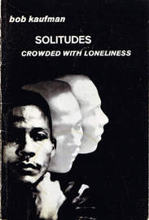
One day, I offered him a coffee. He hunched over it, cradling it in his hands, and apropos of nothing at all, said, “I’m a fountain of Negro, Jewish, and white mysteries trying to get out of my little blue man.” Then he wandered off, down the streets in his cast-off clothes, trailing a roll of poems that he was in the process of writing. I felt glad there was a place in that community of poets where it was okay to be different, to be rootless, to be a frail beatnik incarnate. He often recited at the Coffee Gallery, a fish bowl of glass windows on all sides, open all hours. A resident group of lost souls filled the corners, sometimes for days, as if part of the furniture. Their empty, ghost-like eyes flickering about with vacant stares was enough to put one off drugs for life. Short plays were staged, poetry readings were accompanied by jazz, people danced and at times all those activities took place simultaneously. The creative abandon even extended to the way people spoke; they used words experimentally, just to see whether they could create a new meaning and when, as happened occasionally, the words actually did mean something, it thrilled and surprised us all.
I knew being a beatnik was not just about eating bagels and discussing Nietzsche, but in my innocence, I thought this alternative culture might lead to women being treated with equal regard or at least as individuals, but that wasn’t even on the cards. It was not unusual to hear a beatnik say, “You chicks can’t ever be as clever as us. It’d take you a few hundred years,” or, “You ain’t gonna change the world, baby. It’s just the way things are.” At times they chanted almost like a mantra, “We are anti-conformists. We have no rules,” yet unwritten rules existed, especially rules dictating the sexual behavior of beatnik chicks. I might have wanted to be free of the burden of remaining a virgin but beatniks trying to shackle women with the rule that they should be common, available property, was as threatening and confining as the sexual constraints of normal society. I often heard beatnik men proclaim their sexual generosity, stating they were more than willing to ‘share their chick with a half-dozen guys’. In the same breath, they might even declare that women were no longer considered property, without the least perception that she might belong to herself. The message was clear. If a woman wanted to be accepted as a beatnik, she had to be willing to be fucked by anyone who wanted her. Whatever she chose, she was clearly fucked over. Worse yet, birth control was hard to come by, and male beatniks, happy to populate the world with replicas of themselves, had no intention of fulfilling the generally accepted role of father. My disillusion with this rebel society was growing as I slapped away the hands that tried to grope me in bars and cafés, shouting; “I am not your common property!”
I refused their pseudo-intellectual pick-up lines: ‘You should flow with life,’ or ‘Get in touch with your sexual being’. I turned a deaf ear when they called me bourgeois, inhibited, or puritanical. Showered with attention, Suzan would blossom like a thirsty flower. Beatniks preying on her desire to be part of the scene bombarded her with accusations of being uptight if she repulsed them; black men used the argument that her refusal was racist. It might almost have been funny had it not been so sad. Suzan was clever enough to get by, but not what you would call a deep thinker. She had nothing to lose by refusing, but fearing their scorn; she lived from one disappointing liaison to the next and ended up losing her most precious asset, her pride. After a month or so of this feeding frenzy, Suzan returned to Canada, alone.
It was clear to me that I would never be accepted or fit in with San Francisco’s ragbag of outcasts. I wasn’t joining, but I wasn’t leaving. I was still on my way to Europe, which would require a lot of ‘rabbit’, so I went job hunting. Fisherman’s Wharf seemed like a good place to start. Walt Disney must have inspired the builders as the area had been turned into some sort of comic strip. The kitsch Hawaiian restaurant where I applied for a job fit perfectly. It was dark, almost cave-like, lit by colored lights that sparkled off walls covered with nets and shells, Hawaiian music blared out non-stop and the food, very ethnic, or so I thought, was served with alcoholic fruit punches. In spite of being neither 21 nor a US citizen, I got the job. Each week I fed the boss another excuse as to why my papers had not arrived. Finally, a friend advised me to fake the right to vote. For some reason that right to vote pacified the situation for a few months and, thanks to generous tippers and free meals at the restaurant, I piled away money for my trip to Europe.
Determined, as I was to have men on my own terms, I was about to discover that my smug indifference to sex was no preservative. Through my own ignorance I was about to fall into the same infernal trap that lay, in those days, just below the surface for any young girl who stepped out of line. It all started very romantically one afternoon as I sat with a few friends, eating a double-decker sandwich in the local Italian café. A young man, perhaps ten years my senior, entered the café and took a seat quietly in the corner. He radiated such a vast separateness I could not keep my eyes off him. Only with reluctance did he join us. Like a sudden tug from the past, his curious Bronx accent brought back memories of Damon Runyon radio stories. A voice that could leave egos dangling like abandoned marionettes as its soft tones curled about my heart.
Dante grew up on the East Coast of America, the child of Italian emigrants from Calabria. The early years with his alcoholic father followed him like a sinister shadow. Too restless to stick at anything, he took pride in his rootless existence spent bumming around, joining the Civil Rights marches with Joan Baez. During his military service, the authorities discovered his high IQ and offered him a university place. He completed a few years before drifting off to San Francisco’s intellectual and poetic environment, where lack of worldly success and a sporadic education often added special distinction. It should have been a new start, but he couldn’t shake off the idea that the world should answer to him, and was angry that it refused. It made him all the more exotic: the outsider, a self-declared black sheep, not even fitting in with the beatnik community. Being both an anarchist and a drifter, Dante might well have found himself in similar circumstances to those two anarchists, Sacco and Vanzetti. Like them he might very well have said, ‘Had I not been accused of un-American activities, I would have spent my life discussing anarchy on street corners’. Later he admitted he was more a renaissance man and as a lifelong student of literature and sciences he later became a Master of Arts in Liberal Arts at San Diego State University.

Joan Baez - Martin Luther King in the Civil Rights Movement
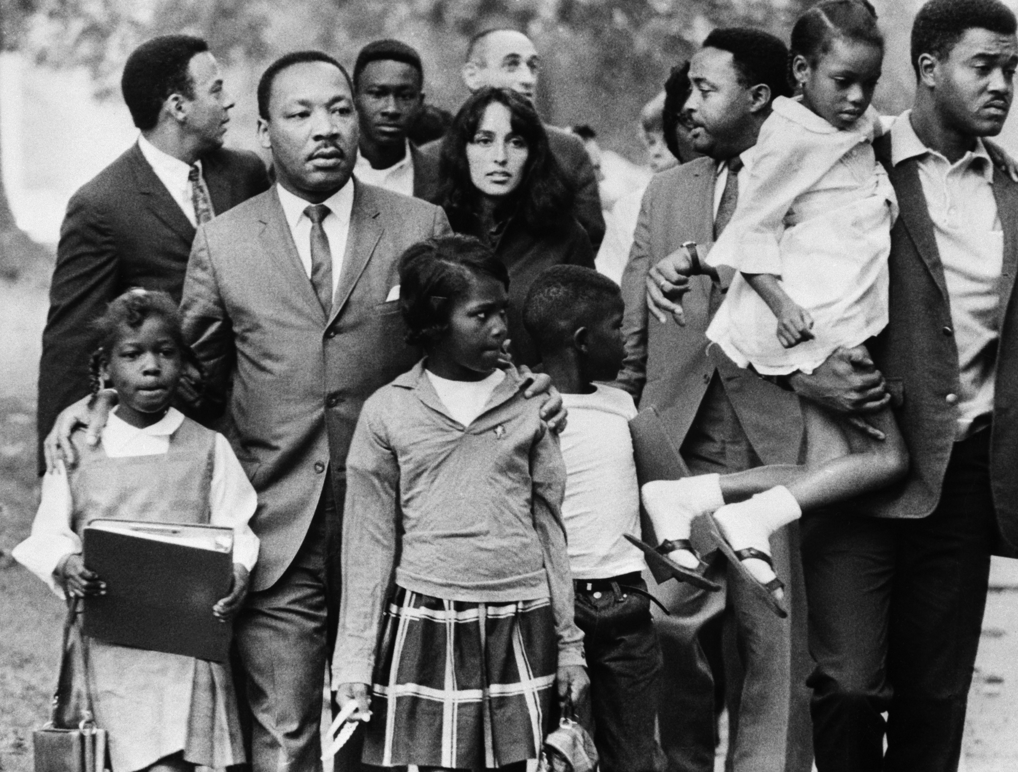

Of course, when you meet a guy you like, up comes the question; are you going to do it or not? I’d lost my virginity at 16, as well as my interest in sex. I guess when I tried it with Dante I was hoping for some kind of miracle, but it didn’t happen. Instead, I felt the same vague disappointment: is this all? One day, to my surprise, I had an orgasm. How it happened was a mystery. I’d read about orgasms, but most books seemed to skirt the subject, hinting at some vague sensation of ecstasy not all that physical; not in the least like the ocean of mixed sensations that sloshed around my body while my shipwrecked brain tried to make out what was going on. After that sex was a tiny bit more interesting, but since my generation was often so full of inhibitions and misinformation, sex wasn’t much fun until later when men started to ease up on what they felt was permitted.
It now sounds ridiculous, but what they thought was permitted before the1960s was mostly limited to a guy getting on top of a woman and pumping away till he had an orgasm.
I was of course pretty ignorant myself, and that ignorance extended to the belief that it was not quite proper to know about contraception; best to leave birth control to the man. Before long I skipped a period and found myself face to face with a sympathetic but resigned doctor. “My dear,” she said, “I understand and weep for you, but this is America. What choice do you have?”
When I look back I see women in that beatnik world waiting for sadness to happen. Like me, they didn’t see it coming. The doctor’s words, ‘You are pregnant,’ made me feel like I had rented a room in hell. I walked out into the street and sat down at a café, indecision turning into agony. The first thing that caught my eye was a couple walking down the street. It was obvious she was one of those beatnik girls, carrying her baby and following her man, while struggling to make enough money to stave off hunger. I knew the type. She didn’t look too good around the edges, kind of like a flower cut from her roots. As I watched, her beatnik man stopped one of the tourists, a guy obviously hanging out in North Beach hoping to pick up one of those loose girls. The beatnik indicated that for a few bucks, the tourist could have his wife. “It’s too beautiful, man!” he said to the guy. “She’s such a whore, she’ll screw anybody for me.”

San Francisco Poetry Reading
My mental state was so unbalanced that the minutes rolled back rather than forward as I imagined getting up and beating some feelings into the man. Instead, I decided I had seen enough of those immoral men and masochistic chicks to know that I wanted no part of their world. Things were not getting better for women; things were getting worse. The so-called poets and artists seemed to expect women to have their babies and take care of them financially, even to the point of selling their own bodies. One evening after work, I arranged to meet Sandy Joseph, Dante’s best friend. Beatnik bonding included bonding with your mate’s chick, and Sandy was no exception. He had the dark-skinned beauty of an Egyptian drawing and the adolescent grace of a boy, yet he rarely had a girlfriend. Perhaps women were put off by the way he carried perplexity around with him like a pet he was nurturing. His hero worship of ‘Dante’s chick’ was very appealing, especially as he was always ready to accompany me to poetry readings and jam sessions.
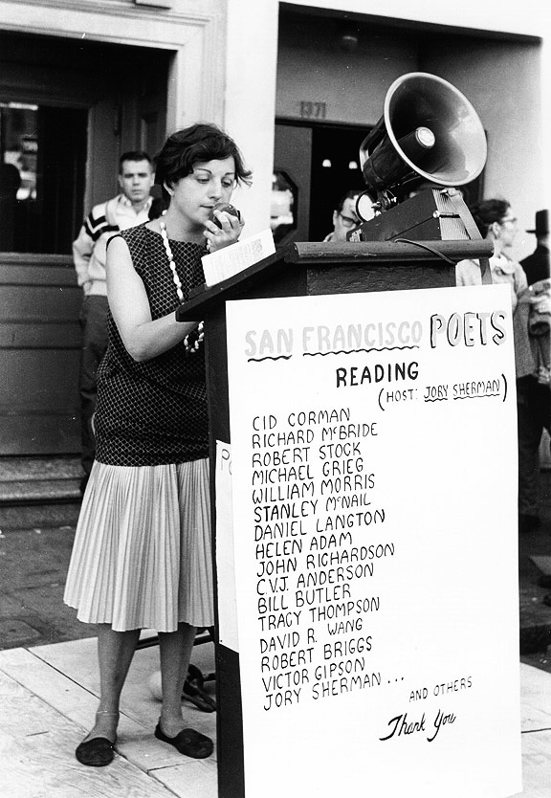

Elise Cowen
Usually the music in those cellars was pretty down-market, but one-night three great horn players were competing against each other with vigor. During the break Sandy came along with a dark-eyed girl a few years my senior. “Hey, Karen,” he said. “Meet Elise. She’s just stepped off a long-haul buses and now she’s living in the same cheap, smelly hotel as me.” The cellar was dark, and I didn’t get a good look at her till the next day when we met for a coffee. It was obvious Elise was both glorying in the wrecking of her own body and doing it with a vengeance.
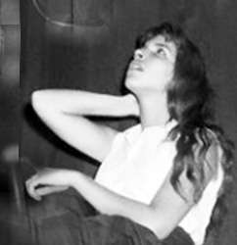
Elise was born in New York and lived off Tenth Street. Her favorite topics were heavily intellectual, and often I just listened as she was above me in her level of education. One evening she leaned over the table in Vesuvio and said, “Look at the root.” her voice twittered in that special East Coast accent. “Society is diseased. It’s all ego! We’re just internal intellectuals screwing up, but it doesn’t matter. We’re into something big that our parents can’t understand. Now we’re just a handful of people listening to each other, but it won’t always be so.”
She hinted that she was on some kind of quest for personal retribution, out of rage against the mortality that threatened her friends. Her friends, I soon discovered, were all the people I wanted to meet, people like Kerouac, Ginsberg and Willem de Kooning.
“New York wasn’t good for me,” she said a few weeks later. “I got into all the stuff nice Jewish parents don’t like.”
She didn’t seem to be getting into good stuff in San Francisco either, and I suggested a walk to the bay.
Elise admitted she wanted to be an artist, but her parents objected. “‘You will get into bad company, drugs and’ – without actually saying the word – ‘sex’. You know the usual story. They came to America after the war, just happy to be alive. They were always talking about how good America is – free trade, free market, free press, but my freedom really scares them.” She smiled one of her rare smiles before adding, “I am free. I know it, but they think of me as an awkward dog that needs disciplining. That’s why they sent out the men in white coats to lock me up for months. Now I’m in hiding.”
I was horrified. I thought Elise was unusual and courageous, but not nuts. She glanced out to the sea, her dark hair almost covering her face but not quite hiding her tears. The thought went round and round in my head; they locked her up for doing what we all want to do. Live creative lives and hang out with people interested in the same things as us.
“They did it the first time because I wanted to go to Black Mountain College in North Carolina.”
“What’s that?” I asked.
She laughed, but apparently not at my ignorance. “Not many people know about it. It was an unusual experimental college full of extraordinary characters.” She mentioned some names, but I knew only a few like William de Kooning, Franz Kline, and Robert Creeley. It was the first I’d heard of people who would come to mean so much to me in the future. People like John Cage, Merce Cunningham, and Robert Rauschenberg.
“When I got out of the loony bin. I had to stay with my parents. They said I didn’t have emotions like other people.” I stared out across at Alcatraz, the prison where they locked people up for life, but at least they had a fair trial before being shut away. She waved a hand wistfully in the air. “Don’t think I didn’t try. I got a job as a typist. You know. Something acceptable to them. Something normal. Eventually they let me share an apartment with three girls, but it was awful. I wanted to paint, to write, not type letters, so I got on a bus to San Francisco, hoping to meet Robert Duncan. He has a poetry workshop here with guys like William Everson and Michael McClure. I’m hoping to go along and meet them, one evening.”
“It’s over for me here,” I said as I watched the golden dimness of the sun sink behind the dark line of the horizon. “I’m going to Europe. I’m in trouble.” Her gaze moved down my body and stopped just below my belly button. I nodded, thankful that she made no comment.
“You gotta stop in New York, so call Sara, my roommate. Maybe she’ll let you stay with her.”
“Come with me,” I said.
“I can’t. They’d find me if I asked for a passport.”
At the end of the summer, I headed for New York. Dante was too self-effacing to ask me to stay and too much of a decent man to say I shouldn’t go. I wouldn’t have stayed anyway and maybe he knew it. After many airplane changes, delays and stopovers, I landed in magical New York, the city my father had once described as, ‘A city populated by men who resembled hard-boiled eggs and the misfortunate to be ruled by dandies and thieves’.
In that vast space of Grand Central Station shades of light floated under a vaulted ceiling, above crowds that rushed by in all directions. I fished out the number Elise had given me. “Hey, sure. Come to my office,” Sara said. After wandering in a state of near panic, I got the subway to Sara’s office, a tiny windowless closet, hardly big enough to swing a cat. Sara, small and very pretty, gave me a radiant smile in response to my look of bewilderment. “Believe it or not, this is the branch office for a large company, I just answer the odd phone call.” She held up a manuscript. “Mostly I work on my novel.”
That night she took me to the ‘in’ bar a few streets down from Washington Square. The Cedar Tavern was an unimpressive, dark, austere place with faded Hogarth etchings. The women, and there weren’t many, were dressed in black, their faces whitened, their eyes surrounded by heavy mascara. Sara said, “The scene is getting a bit boring. All kinds of new types about, but they aren’t laid back like the jazz guys or the painters. They don’t even talk to you, just jive on about what great writers they are going to be, and get quite aggressive when they can’t make out with a new chick.” In the blur of the smoke and noise, a man got up from one of the benches and waved us over. Sara whispered, “That’s Fee Dawson and the taller man beside him is Larry Rivers.”
Larry put his arm around Sara and asked when she was going to let him screw her. The others laughed while Sara pulled free. “Meet my friend Karen, she’s on her way to Paris.”
“Oh yeah,” said Larry, putting his two fingers up in a rude gesture. “Watch out for those Frenchies. They’re wicked stuff, like characters out of some heavy novel. They’ll give you the ooh and the ahh, but they aren’t real men.”
“They’re not real painters, either,” said his companion. “They don’t have a Jackson Pollock to make ’em magical paintings that can change your life. They’re just reflecting their own sacrosanct egos.”
“Americans are accidents. Paintings are accidents, like ciphers,” someone else said. “We should sell Pollock by the roll. The action is on the wall, part of life. The next thing is graffiti.” These artists were just joking, laughing and mocking each other. Perhaps no one realized that they had actually put their finger on the next important development in art. The discussion went on; the loud voices of the men making the place feel charged with their importance, like a male lair.
One of the girls sitting at the bar came over. “You don’t know the half of where art is going!” With a shock, I realized that she was the first woman, and perhaps the only woman, who had dared to speak. In her look, I could sense her disdain for us, the silent chicks, the ones she assumed hung around catering to men’s egos. I was embarrassed. I might not have been laying down everything for my man like the hip chicks, but in my silence I was little more than a pretty audience. I gazed in admiration at the girl. She was earthy and attractive, with an overwhelming physical presence. No one answered her. She nodded to one of the men and said she was going to the White Horse Tavern. Larry watched as the man rose and obediently followed her. Then, turning to us, he said, “He got lucky.” Years later, in London, I met that impressive woman and discovered she was Carolee Schneemann, the choreographer and often-nude performance artist.
The smoke was thicker and the crowd denser. Franz Kline came in, a cigarette hanging out of his mouth, and sat nearby, apparently drunk. He dominated the room, like a tempest coming at you from all sides, his presence electrifying the young men at the bar. All budding geniuses, all unappreciated, their attitude seemed to say; all trying to be Kline, even to the point of imitating his ill-fitting clothes, his personal idiosyncrasies and his manner of talking in fragmented but hopefully profound ellipsis in an effort to attract the same attention he did.

Sara
When he turned his scrutiny on us, his intimidating leer made me tremble. He talked back and forth to our table in what seemed like incoherent fragments as abstract as his paintings, forcing me to fill in the blanks to make any sense of what he was saying.

It struck me that Jackson Pollock was terribly missed. Everybody, including Kline, had a story to tell about him.
Kline said he and Pollock had once been banned from the Cedar for three weeks, after a fight with de Kooning. Pollock had been so angry that he’d turned the place into a shambles, smashing chairs and knocking down the bathroom door. They were all thrown into the street, where they kissed and made up.
Someone asked, “You really kissed?”
Yeah,” he answered, “but we ain’t fags, you know.”
“On summer days there are tables with tablecloths on the sidewalk,” Larry said. “With a sweep of his arm, Pollock would remove the tablecloth, leaving everything in place, glasses, and plates – the lot!” At one point someone recounted how Kerouac had pissed in a stand-up ashtray. For months after the owner had posted a sign saying, ‘No Beatnikes Allowed’.
My head was getting too full with all these stories and I kept nipping into the toilet to note down what people said. We were about to leave when Allen Ginsberg, looking very much like a college egghead, with owlish glasses and short hair came in with his boyfriend, Peter Orlovsky, a prettier, younger version of himself. Ginsberg seemed to gather everyone in; no one was too inconsequential for him. On closer observation, the paradox was that he never seemed to notice when people disagreed with him, almost as if they were too inconsequential for him to bother with.
Sara said, “Karen’s a friend of Elise.”
“How is she?” Ginsberg asked.
“Making out,” I answered not sure how much I could give away.
He searched my face as if looking for clues. Then shaking his head, he turned away. “I know where she is, but I can’t help her.”
On the way out Sara said, “Perhaps nobody can.”
At times people seemed to be playing games on thinner and thinner ice as if they thought they could walk on water, but that didn’t seem to be Elise’s case so why did her friends talk as if she was already hanging like a dead chicken? She’ll make out, I thought, but she never did. A few months later, Elise was dead. She threw herself from a window; the first friend I lost. I cried at the uselessness of being born to be destroyed by parents, prescription drugs and psychiatrists.
I fell in love with New York and wanted to stay, at least for a while, but I was pregnant, and getting more pregnant by the day. I still have no idea why I thought Europe held out some kind of hope for a quick resolution, but at the time, it seemed my only hope. Reluctantly I got a ticket on a liner heading for Le Havre and returned to Sara’s flat to gather together my meager wardrobe. Sara took pity on me as she looked over my pathetic pile. “You need a pretty dress. You know. Something a bit more normal, something in which you can pass unnoticed, or at least go to a chic dinner.” She took out an exquisite, grape-colored dress with tiny buttons from her closet. “Here,” she said. “Wear it and think of me, of Elise, of New York and how you escaped for us.”
I had ample time to think about my future on the way to Europe. It was a particularly illuminating moment as I shared a cabin with two girls, fresh out of college, on a sabbatical paid by their parents. It was obvious that they would have their sabbatical and return to America to marry a professor or banker, to live in suburbia and have children. There was not a spark of rebellion, not even a desire for anything else. Europe for me was not just an escape from pregnancy, but an escape from precisely their chosen role. And yet, as I hung over the railings of the ship, the waves crashing against the sides of the boat, the gray gulls swooping down scooping up the scraps from the kitchen, I felt lost and as vulnerable as I’d felt when I’d hitchhiked across Canada, putting out my thumb to passing cars on those lonely freezing highways that had almost ended in disaster.

My brother Paul
On my arrival in Montreal Paul had thrown his arms around me, grabbed my small bag and said, “God, you’re cold and wet. Get washed and dressed. We’re going to a party.” That was so like him. He showed me Montreal – a city full of damp snow, and blurred landscapes, with Bohemian cafés in Stanley Street that served coffee and wine, making French Canada seem almost European.
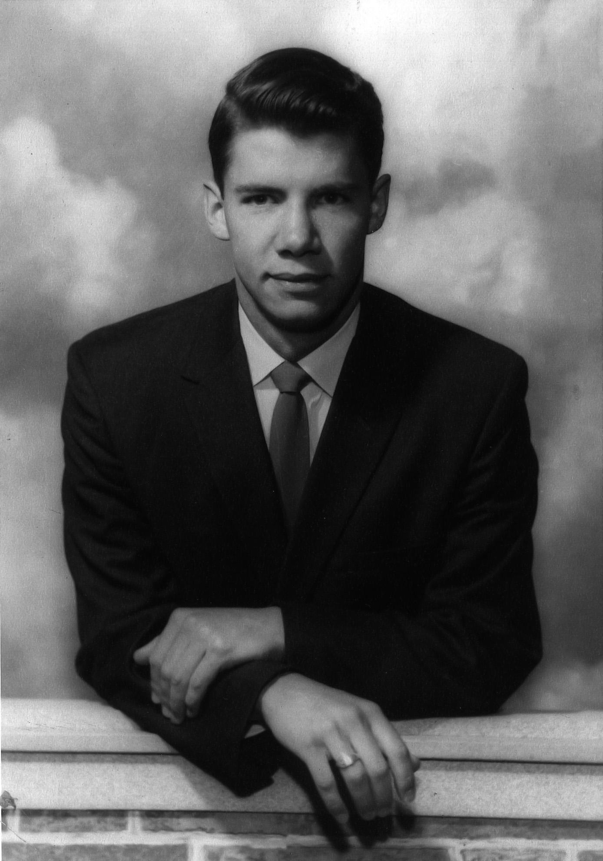
Paul’s bedroom walls were covered with plans for a vertical take-off, flying car that would fit into a normal garage. Those plans brought back a memory of our wandering the hills under a blue sky in search of adventure. Tired and thirsty, we came across a sort of lean-to, likely a prospector’s cabin. We worked the lock and opened the door only to find it was empty except for two trapped hummingbirds hovering in front of the cracked window. Paul gasp, “Gosh, I want to fly like that, and you know, one day I will.” Now it seemed Paul was beginning to fulfill that dream.
Paul was possibly someone who could create miracles; a born manipulator, effortlessly mobilizing all the neighborhood kids to work for him. When he was ten, he built a Ferris wheel but lacking the expertise to ensure that the seats turned properly, chance weighed heavily on the possibility that the passengers would descend upside down. Nevertheless, we all participated, risking our lives and paying our pennies, which my brother, already a budding entrepreneur, demanded. Before the age he could officially drive he built a car from scratch, the first step in an engineering career that would bring his many brilliant inventions to fruition.

Paul’s first Skycar that flue
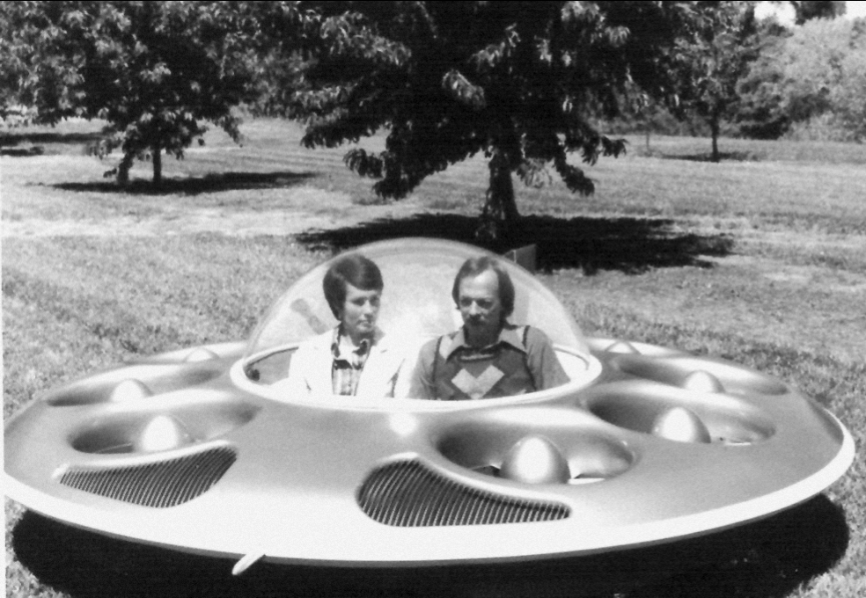
I was pleased he included me in his many projects; we faced the world together like Batman and Robin. Perhaps he considered my apprenticeship permanent. I, however, wanted to be Wonder Woman, the only heroine girls had in those days. In fact, I thought I was Wonder Woman, until my long and complicated return trip to Calgary when that persona deserted me and I returned to being that all too vulnerable young girl.
On the outskirts of Montreal, trying to hitch a ride, the weather worsened and a light snow began to fall. I was relieved when a seedy-looking middle-aged man in a rumbling old Chevy picked me up. What luck to get a ride before the storm hits, but I soon discovered that luck was not on my side. The flabby, red-faced driver was rather drunk and began making suggestive remarks, followed up by several dirty jokes. This looks bad! I scanned the barren landscape for a village or any kind of shelter. When the driver fell silent I began to think he’d forgotten me till suddenly he swerved over to the side of the road, jammed on his brakes, and threw himself on me, pawing and groping me through my heavy winter coat. Once I’d gathered my wits, I slammed my fist into his soft, puffy body, which brought grunts of pain. Opening the door, I tumbled out into the snow. His dumbfounded eyes, full of anger, stared at me. “Ya betta git back in or ya gonna freeze to yur death.”
“So be it,” I said scrambling to my feet, enraged and indignant. With one swing, he threw my suitcase out and slammed the door. Oh my God, I thought. Here I am, stranded on the wind-swept highway in the middle of a Canadian blizzard. Death seemed very near in that deserted, all-white landscape, where no one lived but wolves. By the time a car appeared through the swirling snow, I was frozen half to death and really desperate.
Now here I was in even deeper in trouble. I was pregnant and on my way to France, where I knew not a soul and could not speak the language and yet hoping for a miracle to solve my problem. How it might be resolved, I had no idea except that French women, in defiance of French laws, which criminalized abortion, had been having illegal abortions as a form of contraception since the beginning of time.
All this brought back the stark reality that any fantasy I had of being liberated like my male heroes was simply wishful thinking. A woman would never be free to live like a man. After all, men like Kerouac were guys who hung out with other guys, then slouched off to the next adventure, leaving their pregnant girlfriends to look after real life.

